IDEATION PHASE

DEFINE THE PROBLEM STATEMENT

|  |  |
| --- | --- |
| Date | JUNE 2025 |
| Team ID | LTVIP2025TMID50867 |
| Project Name | ToyCraft tales: tableau's vision into toy manufacturer data |
| Maximum Marks | 2 Marks |

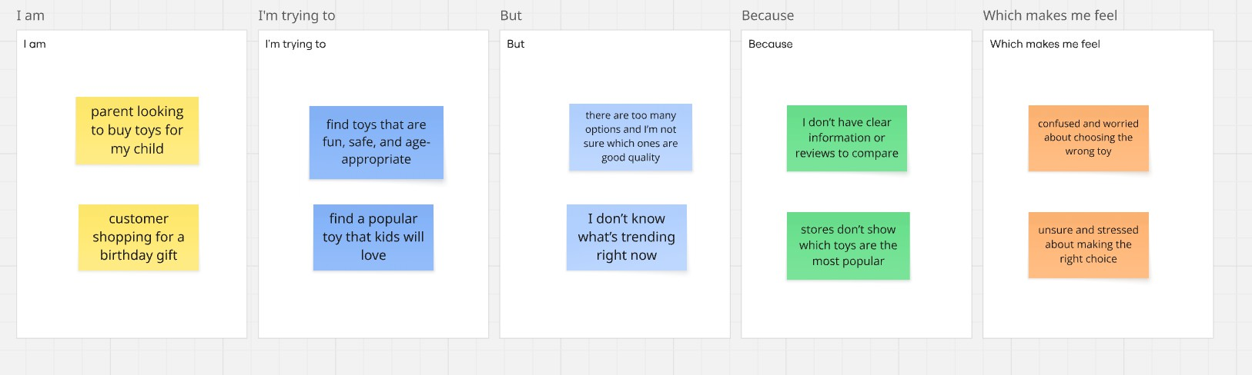

|  |  |  |  |  |  |
| --- | --- | --- | --- | --- | --- |
| Problem Statement (PS) | I am (Customer) | I’m trying to | But | Because | Which makes me feel |
| PS-1 | parent looking to buy toys for my  child | find toys that are fun, safe, and age-  appropriate | I’m not sure which ones are good  quality | I don’t have clear information or reviews  to compare | confused and  worried |
| PS-2 | customer shopping for a birthday gift | find a popular toy that kids will love | I don’t know what’s trending  right now | stores don’t show which toys are the  most popular | unsure and stressed |